1. **Main page**

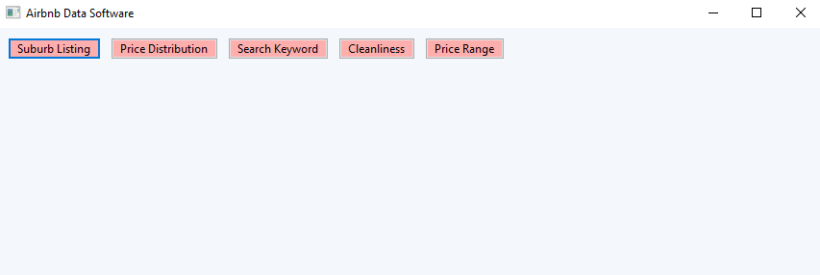

When the user runs the tool for the first time, the above page shows with 5 different buttons of requirements. The user can only run one requirement at a time. Once clicked, a new page will show accordingly.

1. **Suburb Listing Page**

A user should select a suburb, check-in date and check-out date, and press “Search”. Then the tool reports the information of all listings in a specified suburb. If the user leaves any of the input field empty, the tool will not present any results.

1. **Price Distribution Page**

A user must select both check-in date and check-out date before pressing plot.

Once clicked, a price distribution bar graph will show from $0 to $1000.

1. **Search Keyword Page**

In this requirement, a user must select both check-in and check-out date and write any keyword they wish to search for. Then, relevant results will show in a table.

1. **Cleanliness Keyword Page**

A user can select a keyword from the selection.

Once selected and searched, results will show in a table with the listing ID and comments. Also, the total number of results with the selected cleanliness keyword will show.

**6. Price Range Page**

Users can choose the minimum and maximum price of the property and view the listings in a table with its id, name and price.